**Module 5: Critical Thinking**

**Web-based Pothole Tracking and Repair System**

Ryan Thompson

Colorado State University - Global

CSC 505

Dr. Gonzalez

14 July 2024

**Synopsis**

This prototype of a pothole tracking and repair system makes use of Python’s classes for the build. The main script uses the pothole, citizen, and public works classes to build up a work order. At which point the work order is automatically filled with data and saved to a damage report file. This can be done by running the command “*make report*” within a terminal. The prototype does not yet have a front end interface for filing a damage report. However, the terminal based application is able to demo the main functionality of our program by automatically generating a damage report.

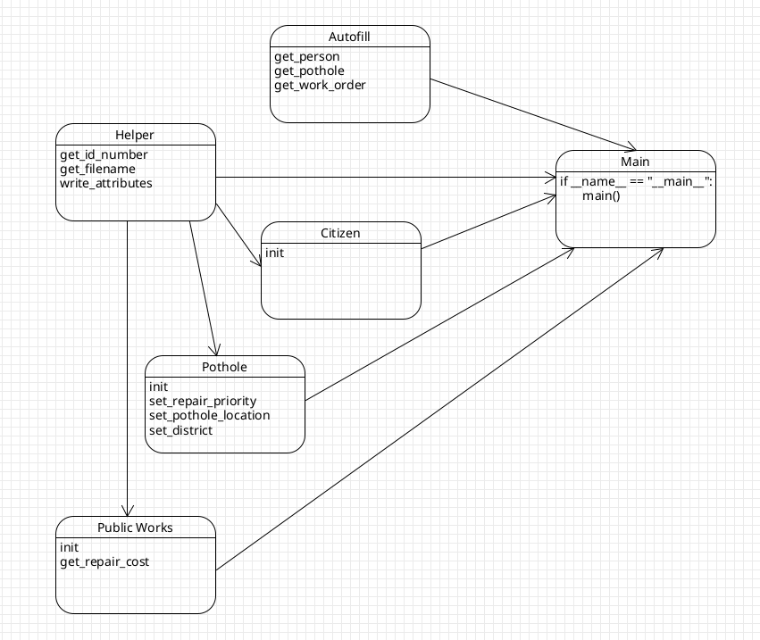

*UML Diagram*

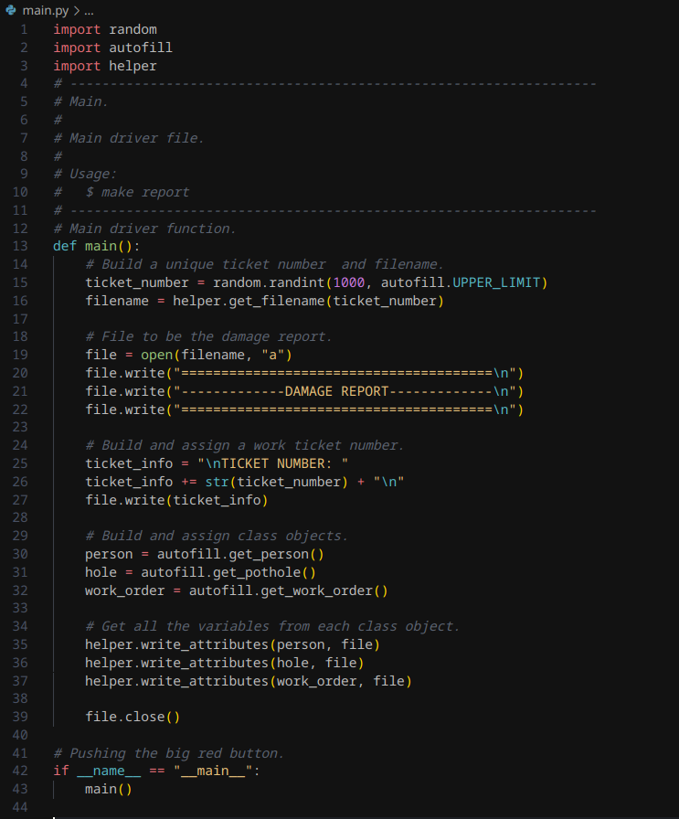

*Main Python Script*

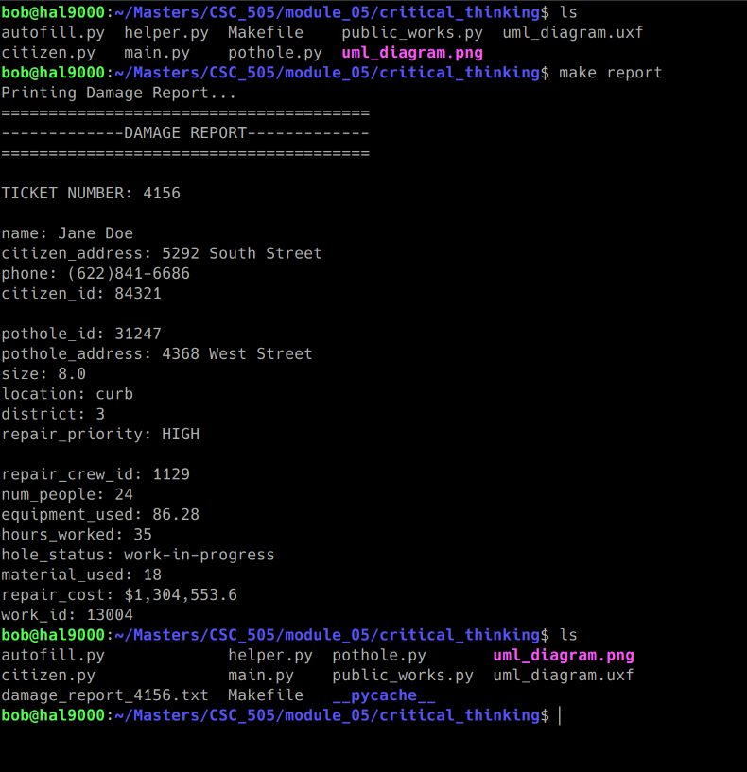

*Program Output*

**References**

*UML use case diagram tutorial*. Lucidchart. (n.d.). https://www.lucidchart.com/pages/uml-use-case-diagram

GeeksforGeeks. (2024, February 9). *Use case diagrams: Unified modeling language (UML)*. https://www.geeksforgeeks.org/use-case-diagram/